Task-1: Creating a Git Repository and Assignment Folders
Student Details
Enrollment Number: 2502031030060
Task: Create a Git repository named as enrollment number and create two folders named Assignment_1 and Assignment_2.
Step-by-Step Process
Step 1: Open GitHub
1. Open a web browser.
2. Go to the GitHub website:
https://github.com
3. Login using your GitHub username and password.
After logging in, the GitHub Dashboard will appear.

Step 2: Create a New Repository
1. Click on the “+” icon in the top right corner.
2. Select New Repository.
3. Enter the repository name as your Enrollment Number.
Example:
2502031030060
1. Select Public repository.
2. Check the option Add README file.
3. Click Create Repository.
Now the repository is created successfully.

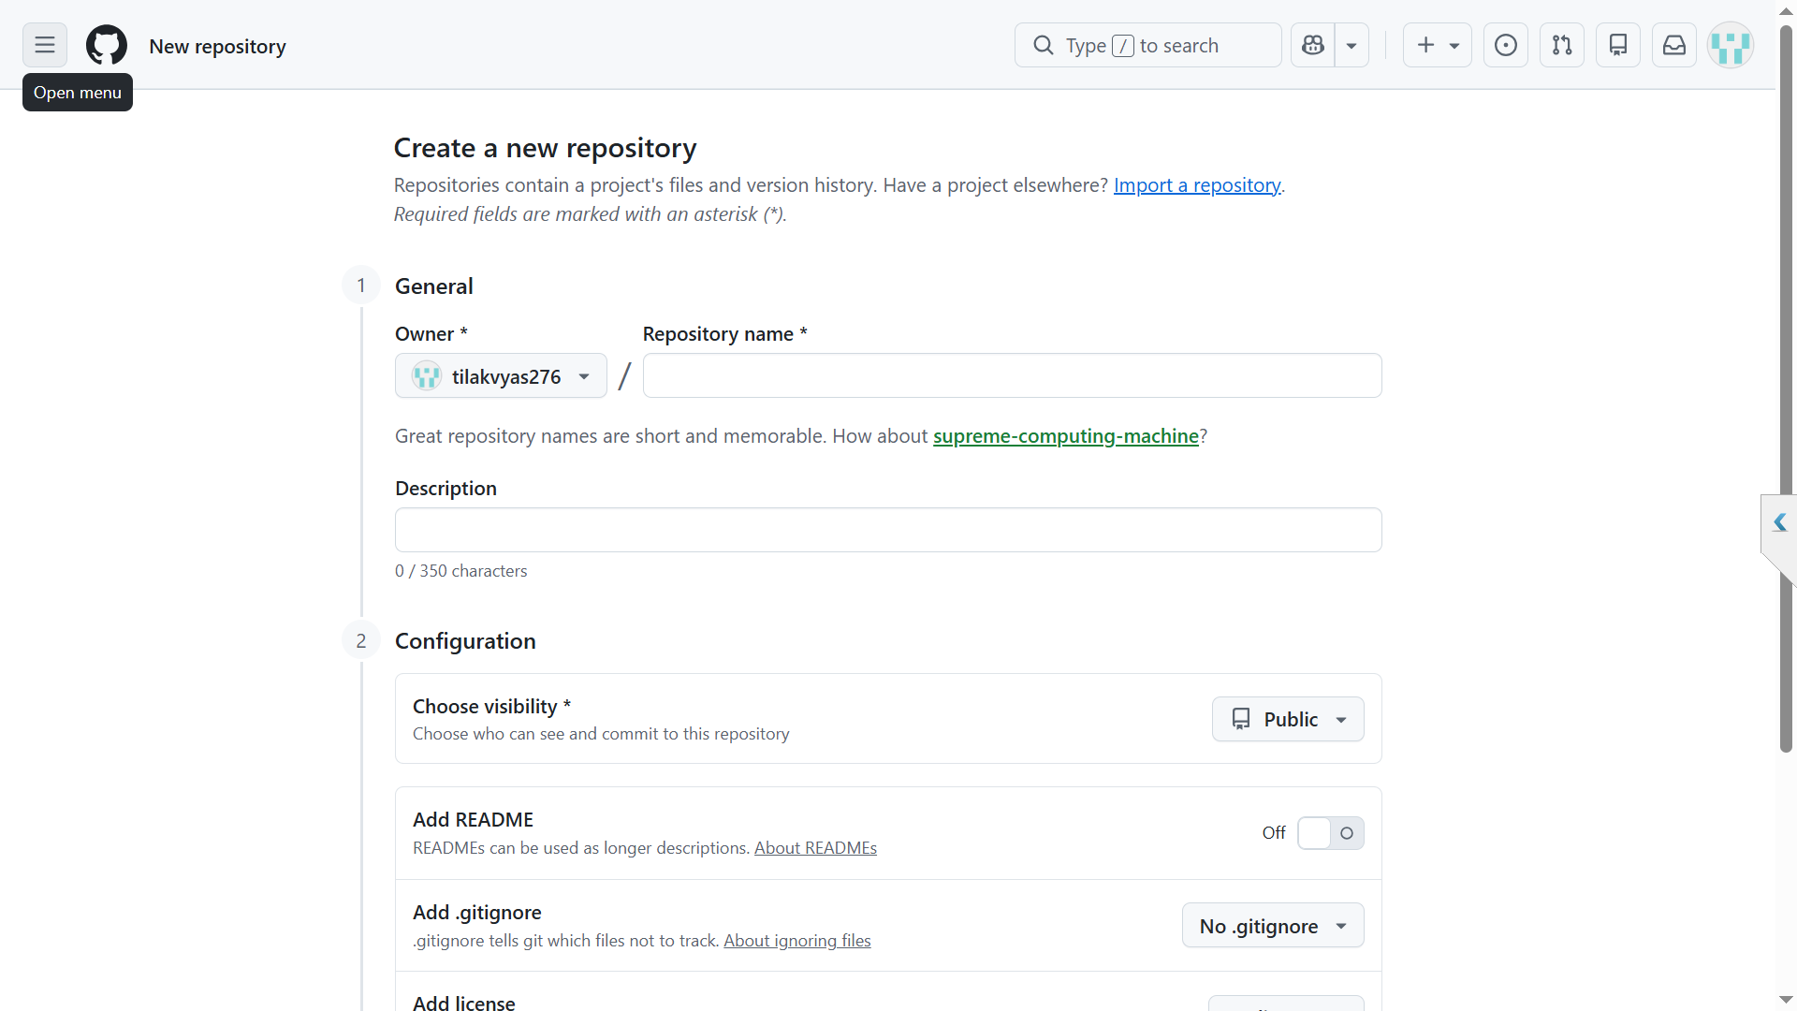

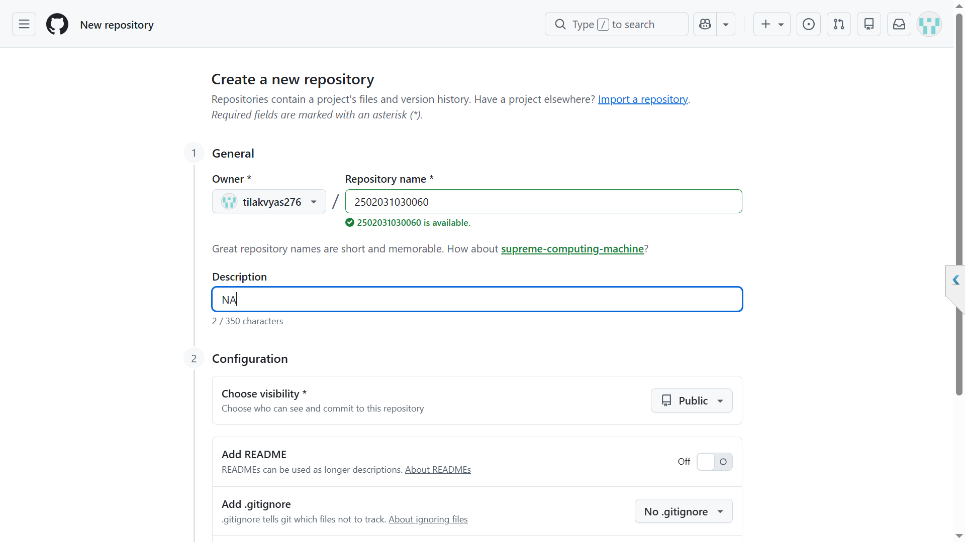

Step 3: Repository Created
After creating the repository, GitHub opens the repository page.
You will see:
· Repository Name: 2502031030060
· Default Branch: main
· A README file
This confirms the repository has been created.

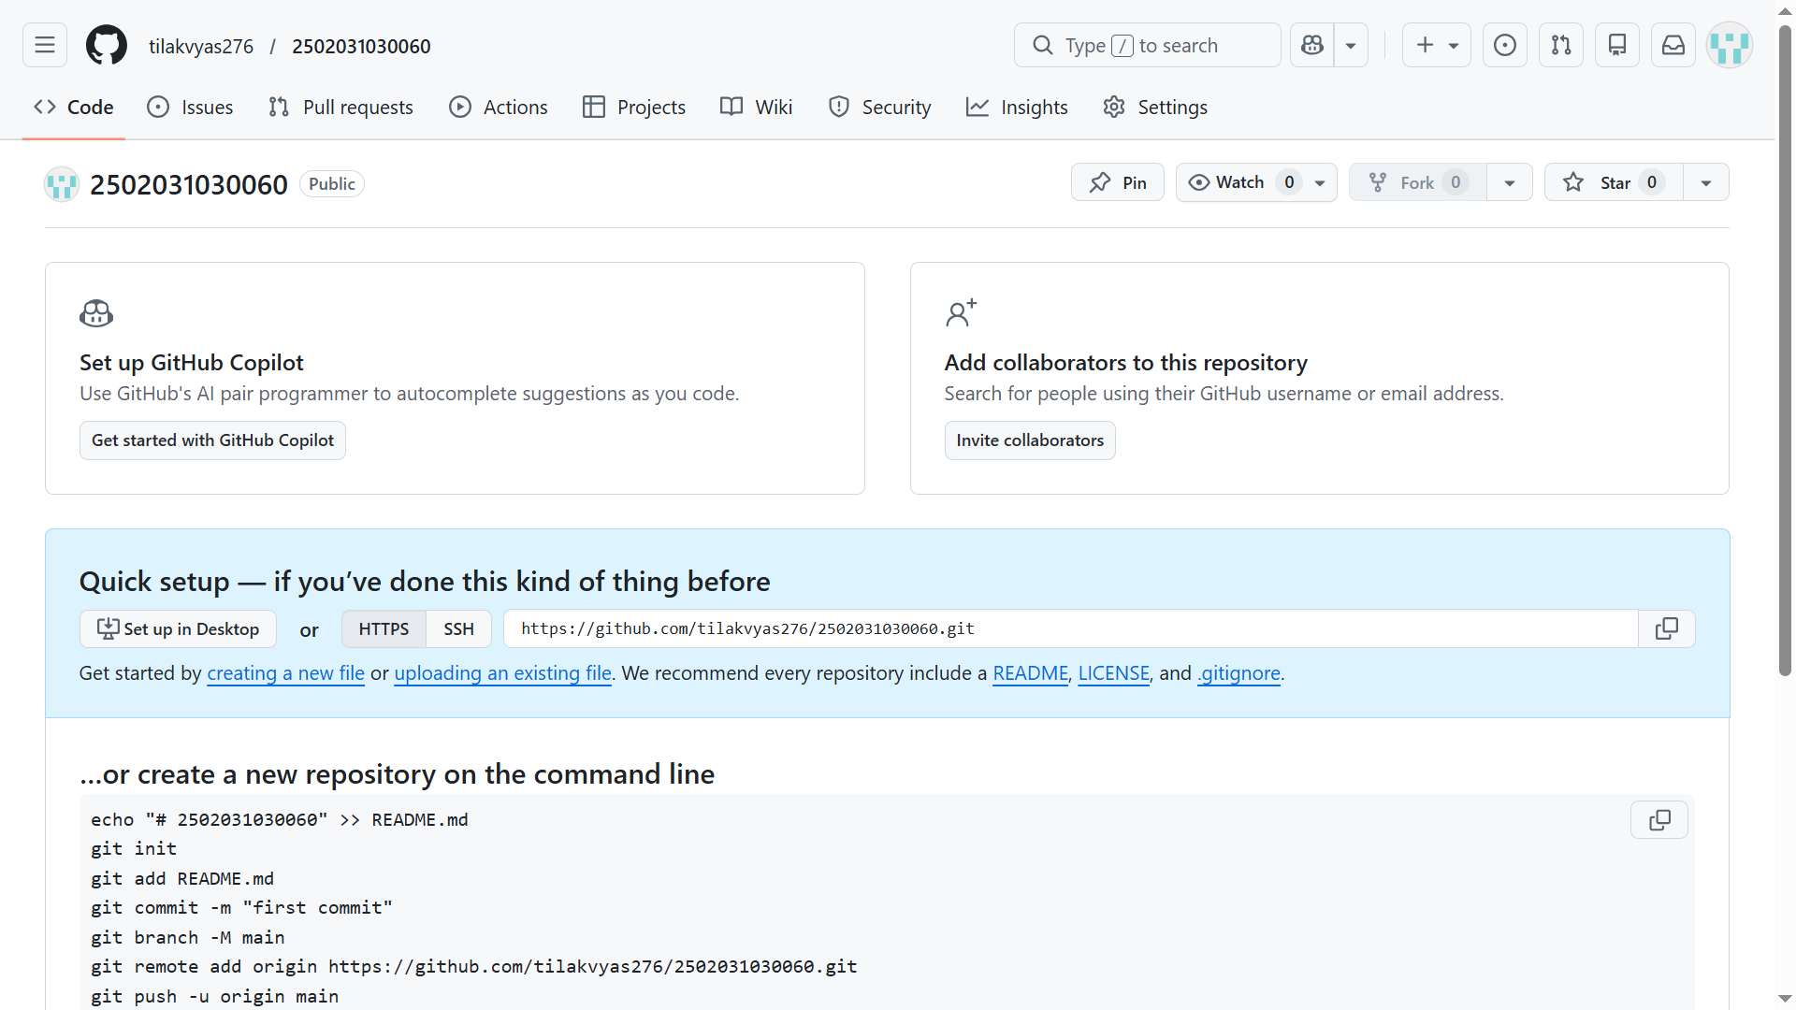

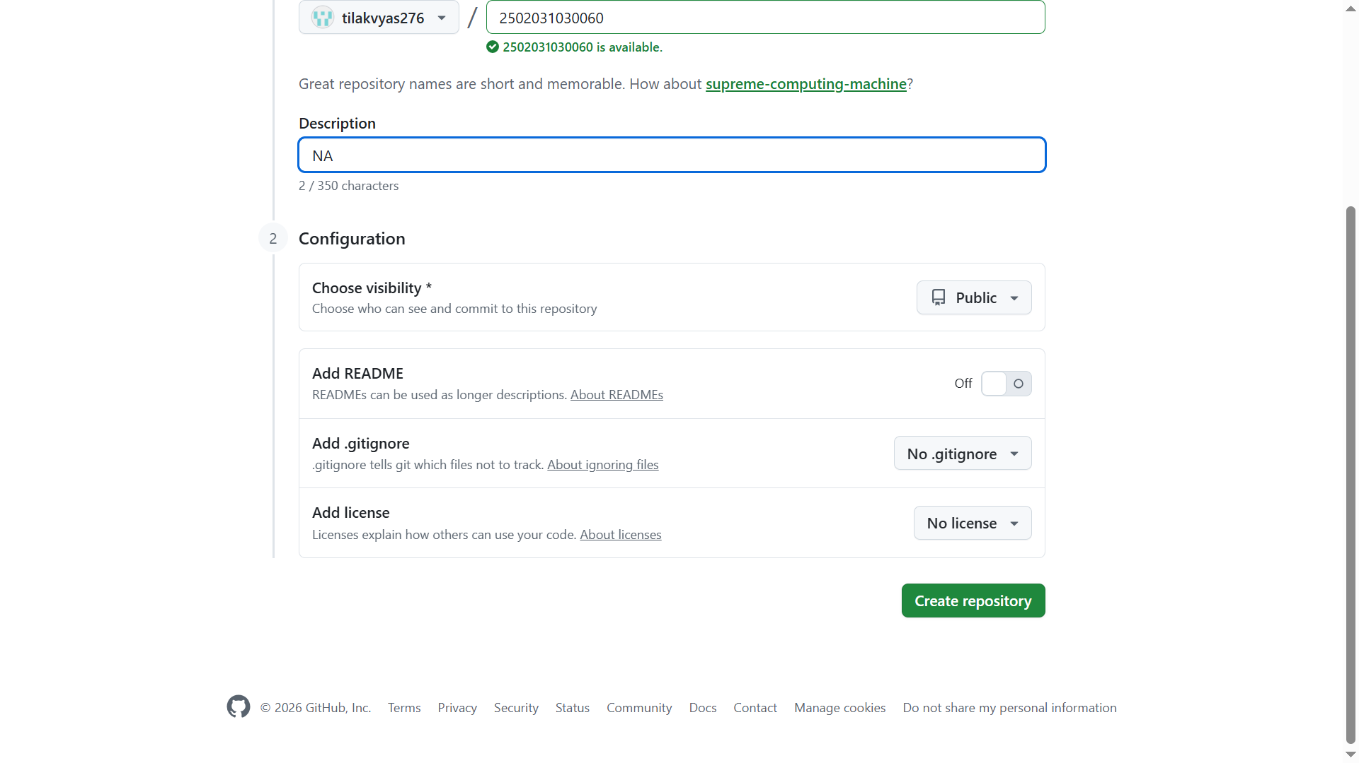

Step 4: Create Folder “Assignment_1”
1. Inside the repository, click Add File.
2. Click Create new file.
3. In the filename field type:
Assignment_1/
1. GitHub automatically creates a folder.
2. Add a placeholder file if needed.
3. Scroll down and click Commit changes.
Now the folder Assignment_1 is created.

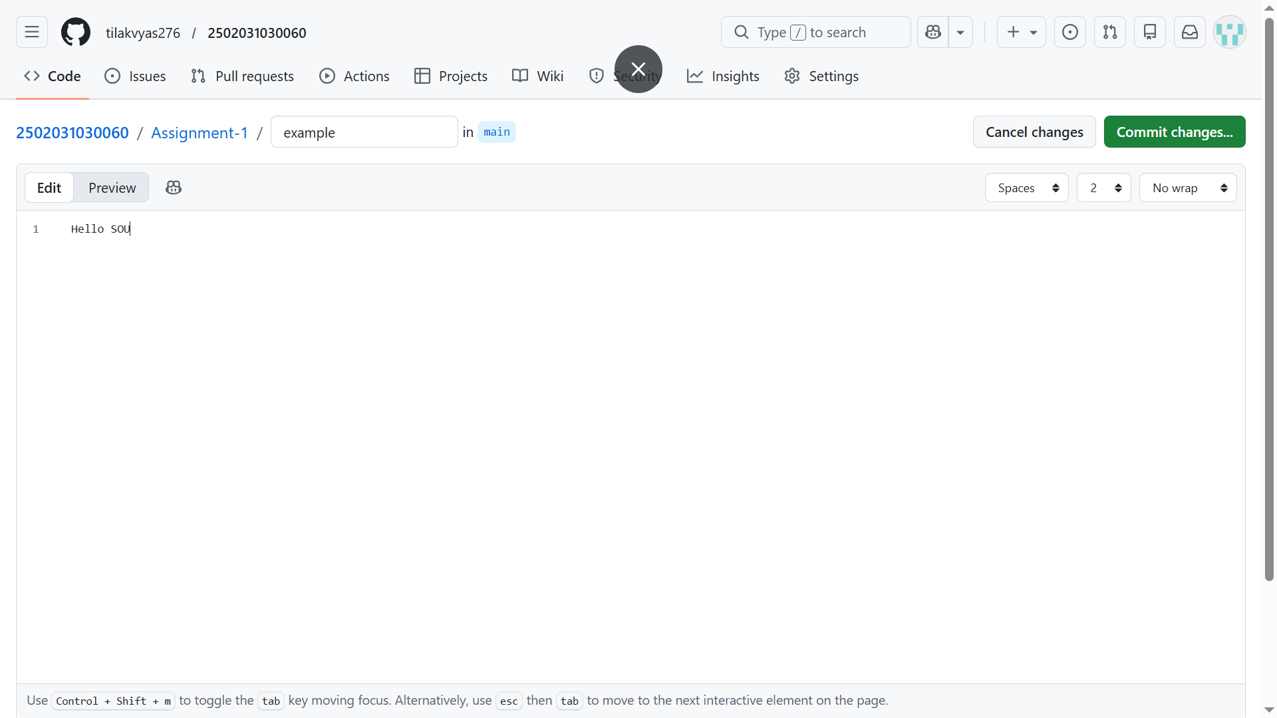

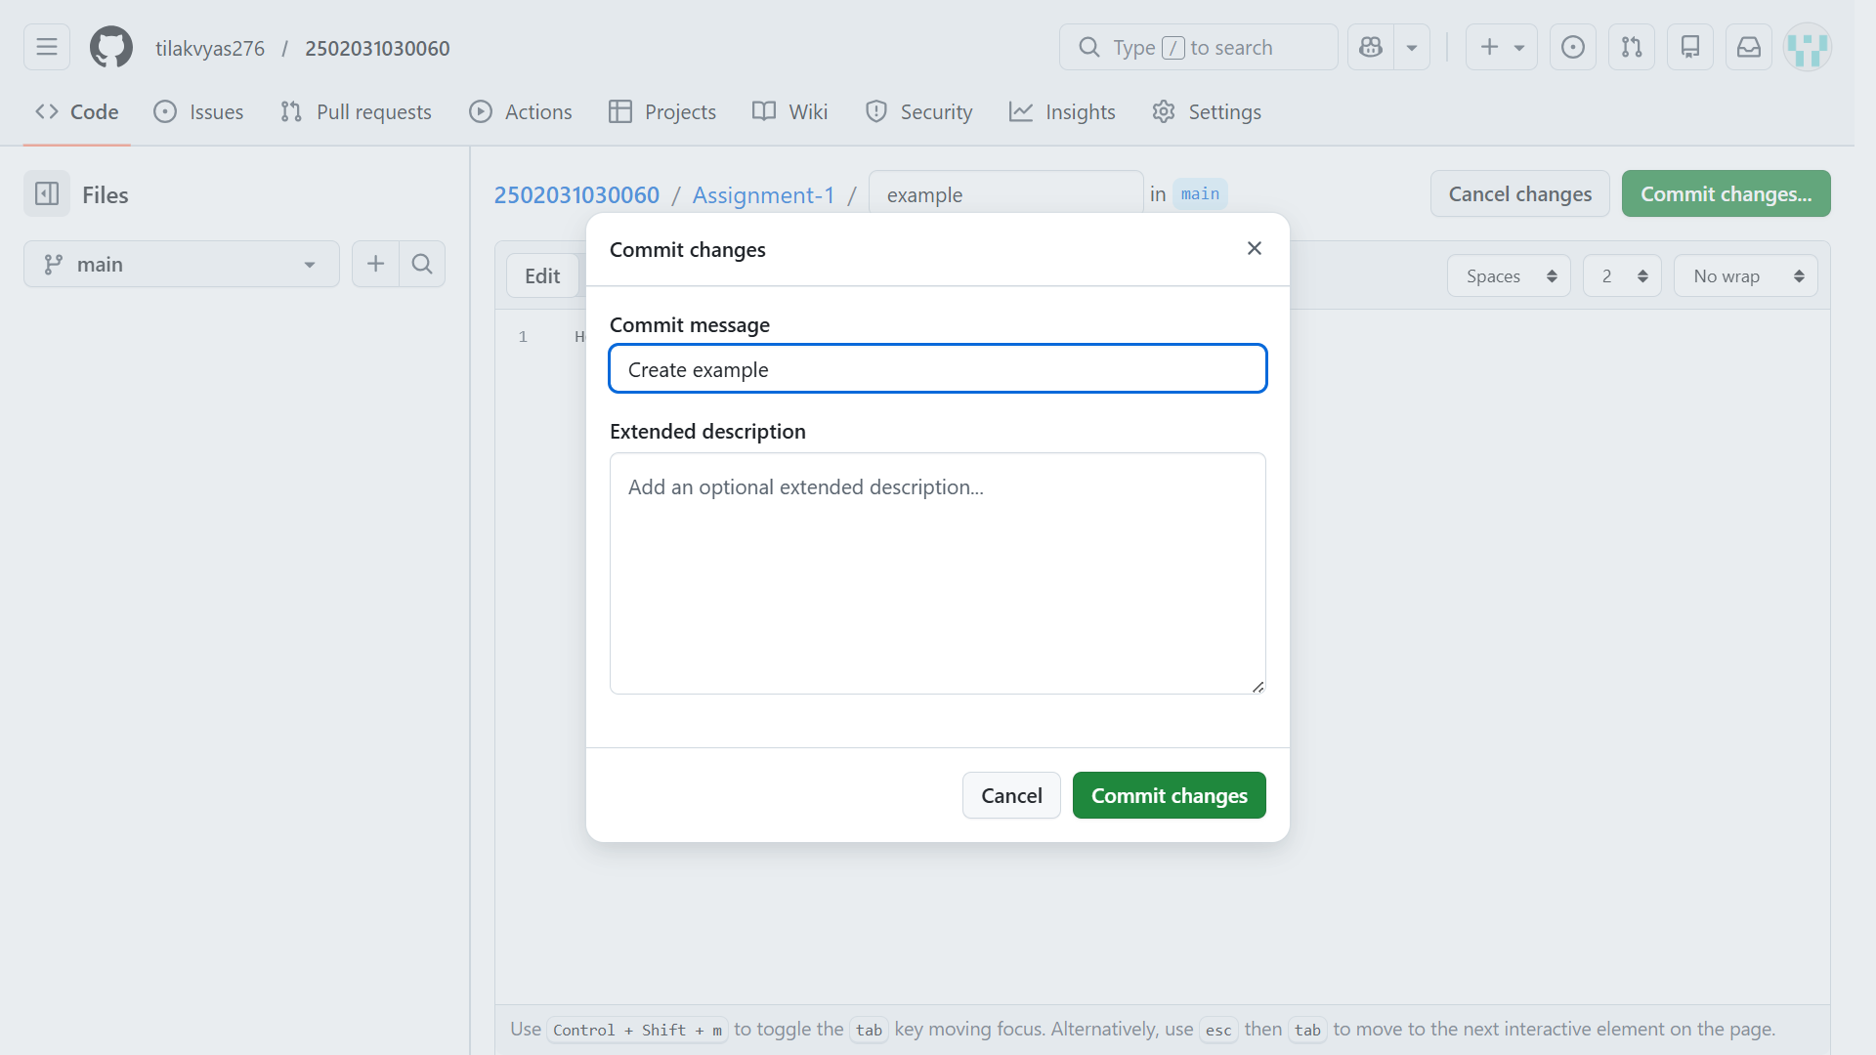

Step 5: Create Folder “Assignment_2”
Repeat the same process.
1. Click Add File
2. Click Create new file
3. In the filename field type:
Assignment_2/
1. Scroll down.
2. Click Commit Changes.
Now the folder Assignment_2 is created.

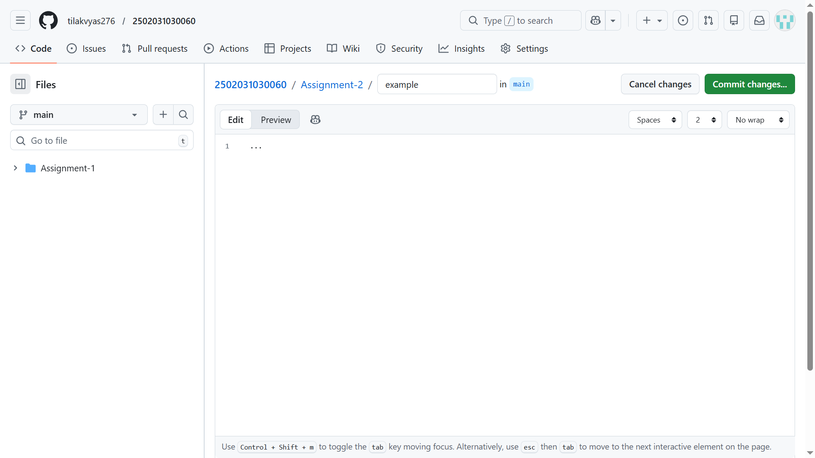

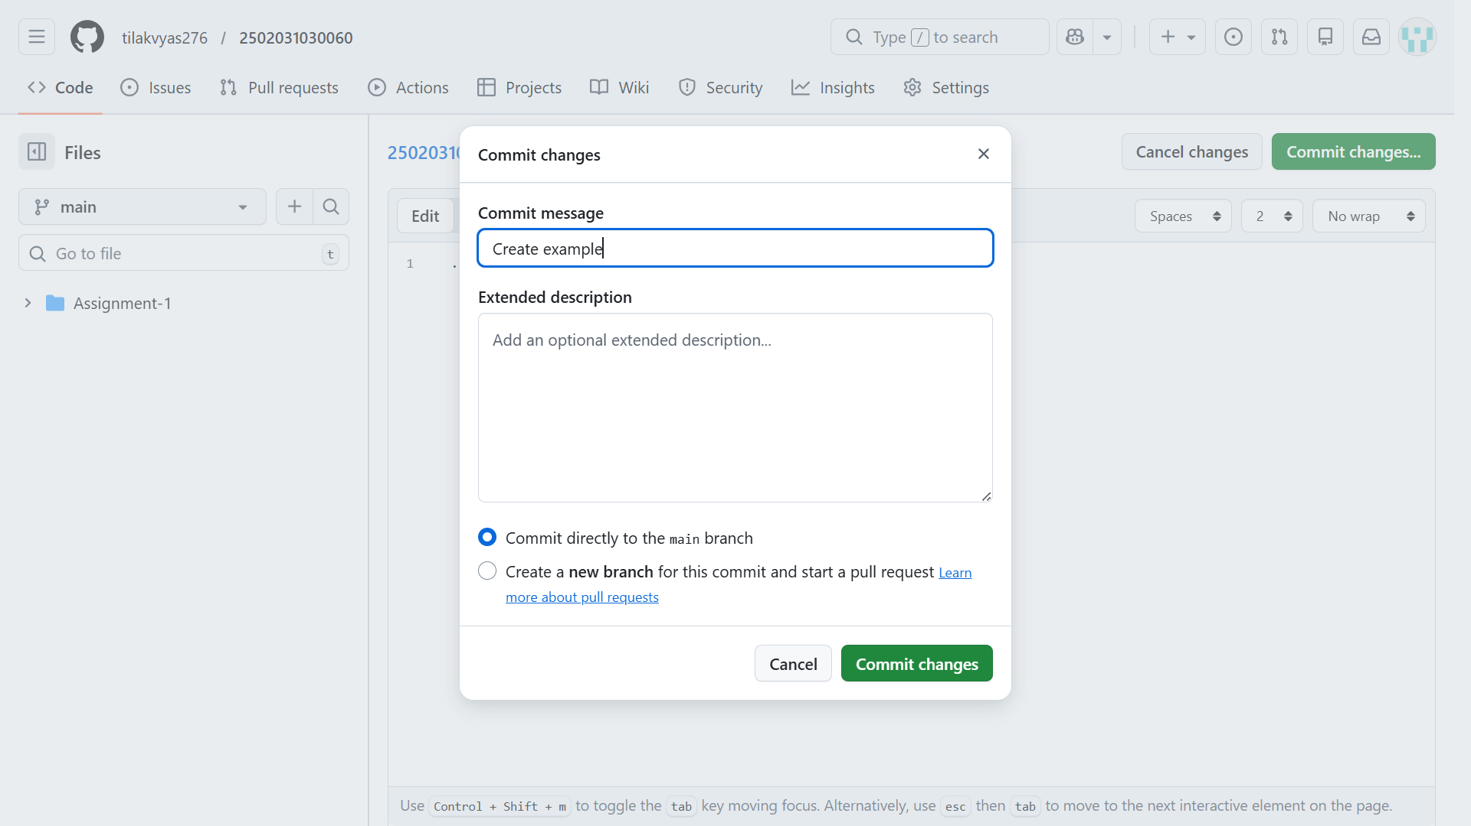

Step 6: Verify Folder Creation
After committing the changes, the repository will display:
2502031030060
│
├── Assignment_1
├── Assignment_2
└── README
This confirms both folders are successfully created.

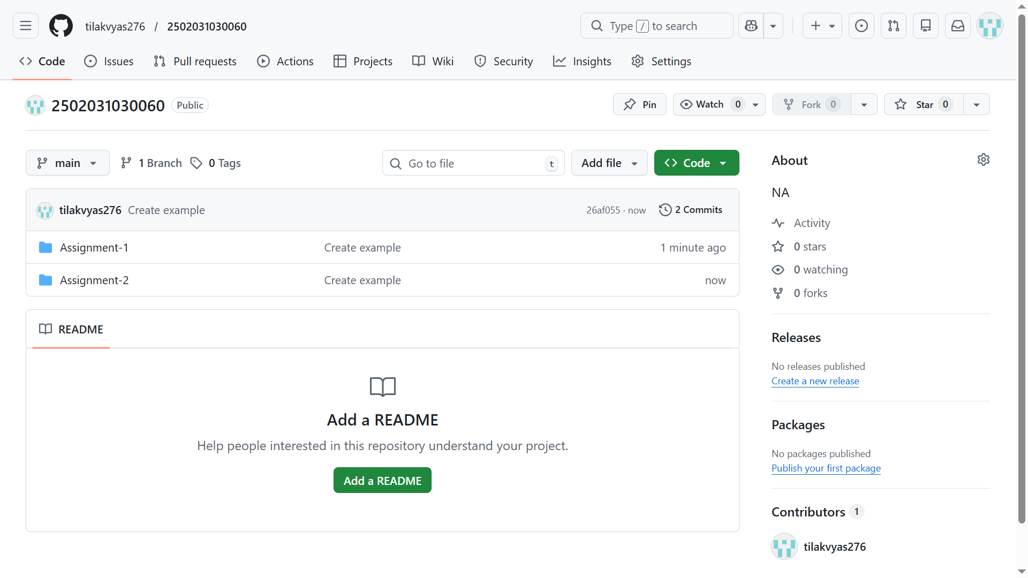

Step 7: Repository Activity
GitHub automatically records the activity such as:
· Commits
· Folder creation
· File updates
This activity is visible in the Contribution Activity section of the GitHub profile.
Final Output
The repository contains:
Repository Name | Folders Created
2502031030060 | Assignment_1
2502031030060 | Assignment_2

Both folders were successfully created in the GitHub repository.
Conclusion
In this task, a GitHub repository named 2502031030060 was created successfully. Two folders Assignment_1 and Assignment_2 were added to the repository using GitHub's web interface. The repository structure and commit history confirm that the task was completed correctly.

